**HOME AUTOMATION USING SENSORS**

Sarath Vignesh A

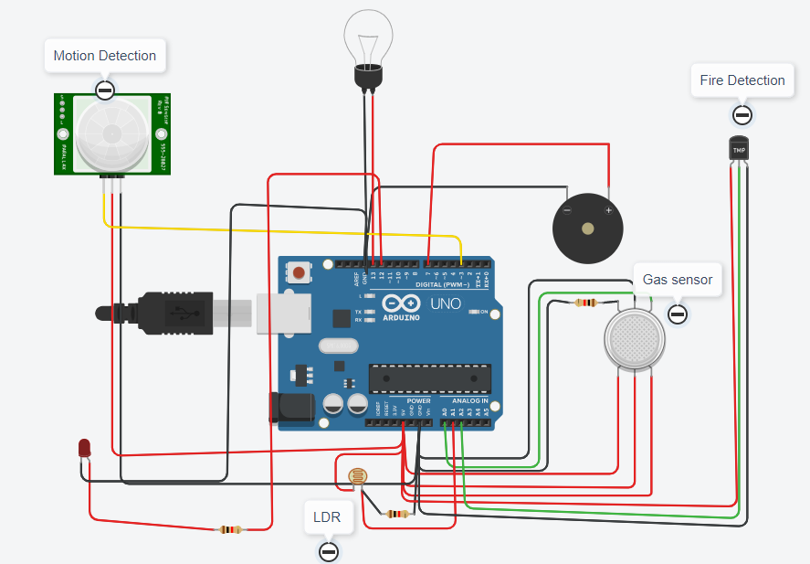

**Source Code:**

#include <Servo.h>

Servo s;

int gas_sensor = 0;

const int bulbpin=13;

const int LDR=A1;

int baselineTemp = 0;

int celsius = 0;

int trig=3;

int ec=4;

void setup()

{

pinMode(A0, INPUT);

pinMode(7, OUTPUT);

pinMode(13,OUTPUT);

pinMode(A1,INPUT);

pinMode(3,INPUT);

pinMode(12,OUTPUT);

}

void loop()

{

gas_sensor = analogRead(A0);

if (gas_sensor >= 250) {

tone(7, 523, 1000);

}

delay(10);

int Ldr_s=analogRead(LDR);

if(Ldr_s<=500){

digitalWrite(bulbpin,HIGH);

Serial.println(Ldr_s);

}

else{

digitalWrite(bulbpin,LOW);

Serial.println(Ldr_s);

}

baselineTemp = 40;

celsius = map(((analogRead(A2) - 20) * 3.04), 0, 1023, -40, 125);

if (celsius >= baselineTemp + 30) {

tone(7, 220, 100);

delay(100);

}

int motion=digitalRead(3);

if(motion){

digitalWrite(12,HIGH);

delay(1000);

digitalWrite(12,LOW);

delay(1000);

}

}

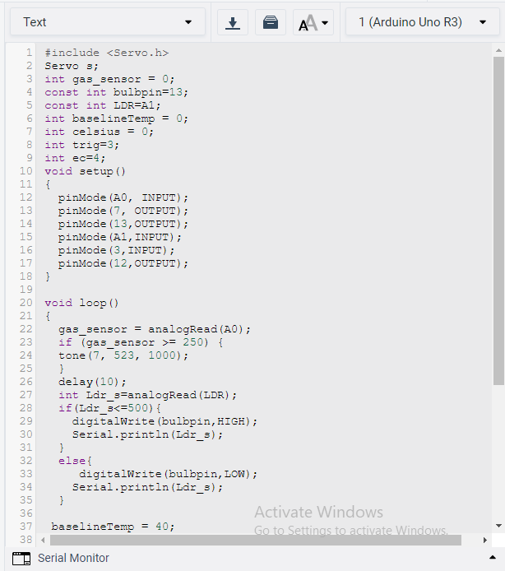

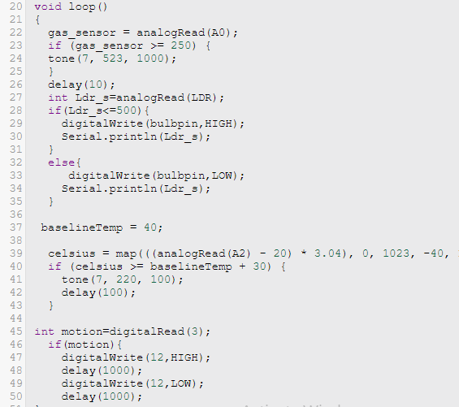

Link to the Project:

https://www.tinkercad.com/things/iQEy3QUJu7C-sarathshomeautomation/editel?sharecode=IuGVn6TLeDPoBRYwMvA5y7rjTqcWn-bgG3jnnkT7Ldo